**Practical 1:- Demonstrate the different types of topologies and types of transmission media by using a packet tracer tool.**

**Output:-**

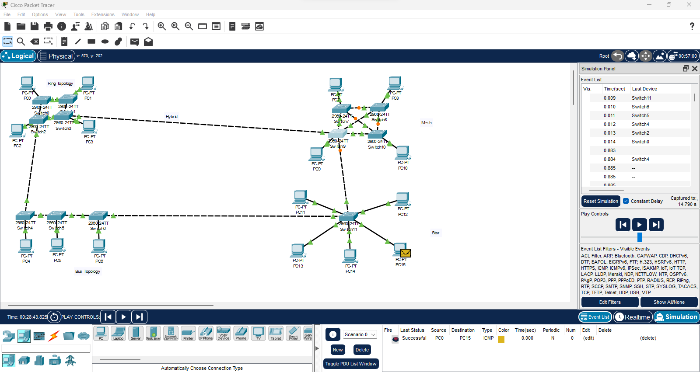

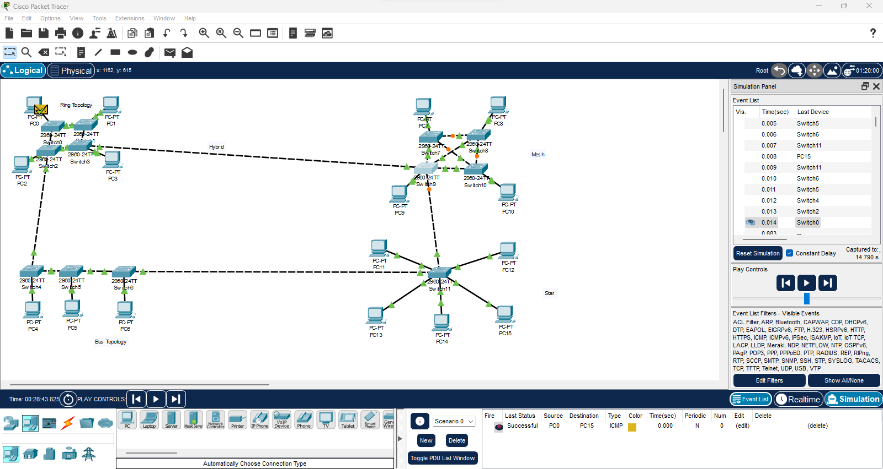

**Practical 2 :-** **Setup a wired LAN using Layer 2 Switch. It includes preparation of cable, testing of cable using line tester, configuration machine using IP addresses, testing using PING utility and demonstrating the PING packets captured traces using Wireshark Packet Analyzer Tool.**

**Output:-**

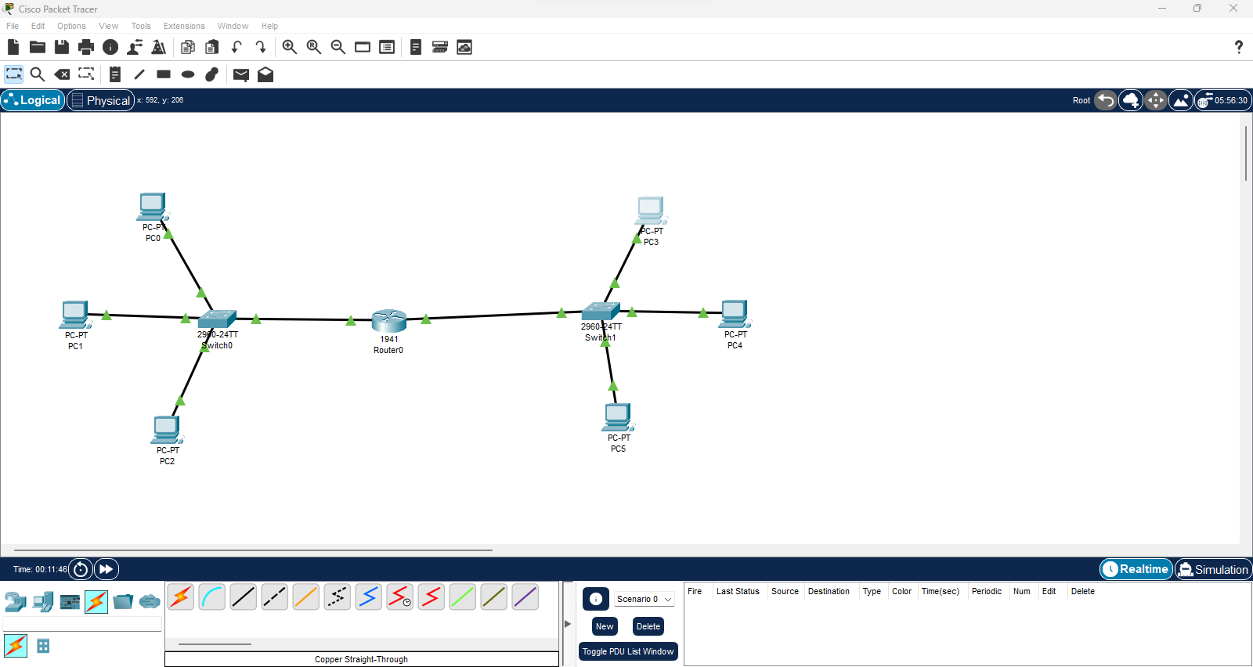

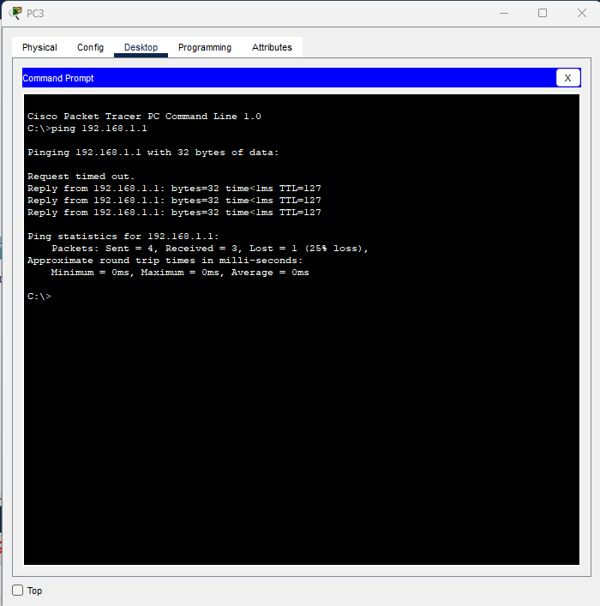 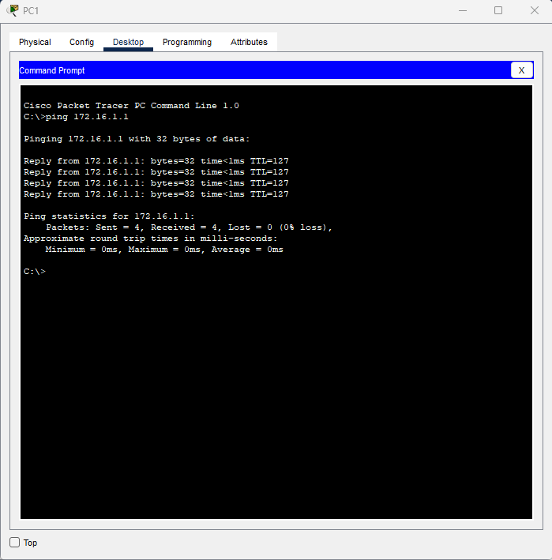

**Practical 3 :- Setup a WAN which contains wired as well as wireless LAN by using a packet tracer tool. Demonstrate transfer of a packet from LAN 1 (wired LAN) to LAN2 (Wireless LAN).**

**Output:-**

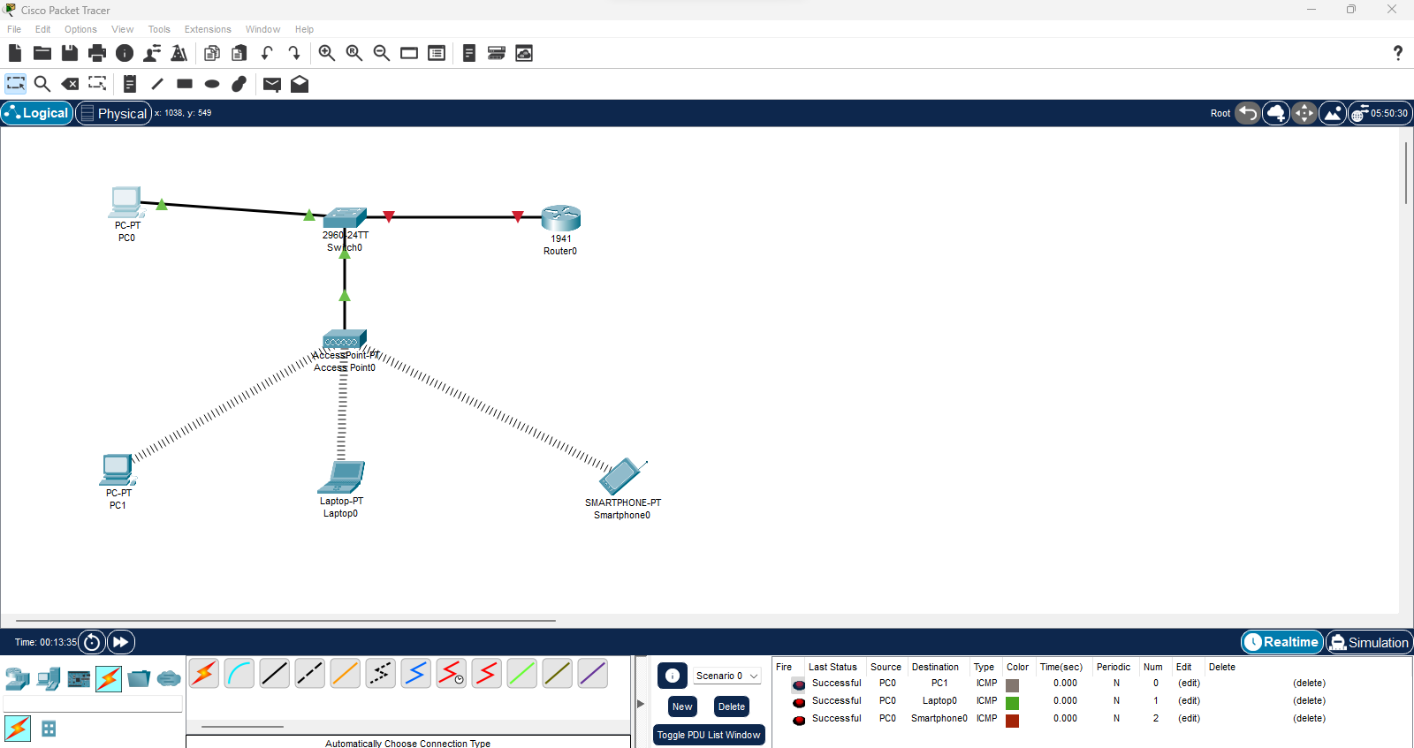

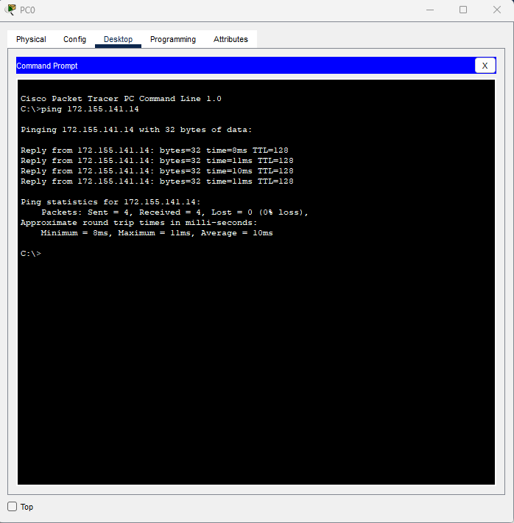

**Practical 4:- Use packet Tracer tool for configuration of 3 router networks using one of the following protocols RIP/OSPF/BGP.**

**Output:-**

